Facial Emotion recognition Using Deep Learning: A Comparative Study on JAFFE and CK+ Datasets

Name: Patel Samira
Student ID : G21163419

Introduction:
The machine-learning detection of human emotional states from facial expressions is known as facial emotion recognition, or FER.
Traditional machine learning methods based on manually created features were used to deal with this issue in earlier research. These methods displayed reduced accuracy, especially for complex or confusing emotions, had trouble identifying minute face differences, and did not expand well on small datasets.
To conquer these obstacles, the current research employs a deep learning method for facial emotion classification that combines transfer learning with ResNet50. Deep convolutional models are more efficient for FER tasks because they can automatically learn complicated and selective visual characteristics. Two benchmark datasets, JAFFE and CK+, are used to train and evaluate the model. Its performance is compared using common classification metrics and visual analysis to measure improvements over traditional methods.

Literature Review:
Facial emotion recognition (FER) has been transformed by deep learning techniques. Because they can directly train hierarchical representations of images from input, Convolutional Neural Networks (CNNs) are very great at capturing both high-level face features and low-level edges.
Transfer learning, in which pre-trained models like VGG, ResNet, also AlexNet are refined on smaller emotion datasets, is widely used in recent FER studies. Because datasets like JAFFE and CK+ have small sample sizes, transfer learning is particularly useful in FER.
Deep learning techniques still have challenges in addition to these benefits. Class imbalance may bias predictions in favour of majority classes, small datasets raise the risk of overfitting, and many FER datasets contain posed rather than spontaneous emotions, which hinders their practical application.
By applying a uniform transfer-learning framework – ResNet50—to both JAFFE and CK+, this work extends on previous deep learning research by allowing a direct comparison of dataset properties and model performance inside a single pipeline.

Datasets:
The two popular facial expression datasets used in this study are JAFFE and CK+, each of which has unique benefits to evaluate deep learning models.
Ten female respondents’ 213 grayscale photos from the Japanese Female Facial Recognition (JAFFE) dataset show seven fundamental emotions: happiness, sorrow, anger, fear , surprise, disgust, also neutrality. JAFFE’s modest size and constrained subject variety pose problems for deep learning, increasing the likelihood of overfitting, although this regulated setting makes it suitable for assessing model performance on clean, reliable data.
593 expression variations from 123 participants compose the larger and more diverse Extended Cohn-Kanade (CK+) dataset. Only each sequence’s peak-expression frame is used for this research. Compared to JAFFE, CK+ is more representative and challenging because to its wider range of age, gender, and ethnicity. Furthermore, a more reliable framework to analyse transferable learning model is provided by its bigger size.
Before training, all photos were converted to RGB when needed and scaled to 224 x 224 pixels to meet ResNet50 input requirements. To provide more equitable learning across emotion categories, class-weighted loss used to rectify class imbalance during training.
Model Development :
ResNet50, a popular convolutional neural network design for image classification, and the deep learning model used in this study. Because it provides a good mix between depth, performance, and computational economy, ResNet50 was selected. The network may acquire more intricate visual representations thanks to these skip connections, which also aid in preventing fading gradients. However, when paired with transfer learning, ResNet50 is much lighter than huge designs, making it appropriate for smaller FER datasets.
Face Preprocessing:
Even if face-centred photos are included in both JAFFE and CK+, preprocessing is still important to guarantee constant input. To match the model’s predicted three-channel input, all photos were converted to RGB format and downsized to 224 x 224 pixels, which corresponds to the desired input size for ResNet50. This standardisation reduces the uncertainty caused by variations in colour channels or image resolution. Advanced face detection or alignment was not necessary because the datasets were already frontal and clean, but the initial treatment procedure ensured that every picture was normalised and prepared for feature extraction.
Model Selection and Explanation:
The study refers to transfer learning, a method which includes applying a previously learned model to a new problem. Because JAFFE and CK+ are too tiny to train a deep CNN from beginning without experiencing significant overfitting, ResNet50 pre-trained on ImageNet was used. The model may reuse low-level and mid-level visual elements that were already acquired from millions of photos, such as edges, textures, and forms, thanks to transfer learning.
A unique output layer that matched the amount of emotion classes was used in place of the original fully linked classification layer to modify ResNet50 for FER. To enhance normalisation and reduce overfitting, a dropout layer was added before the final dense layer. A two-stage approach was used in the training procedure. Only the recently added classifier layers were trained in the first step, with the convolutional base of ResNet50 frozen. As a result, without changing pre-trained weights, the model was able to learn dataset-specific decision limits. The basic network’s higher layers were unfrozen and refined using a lower learning rate during the second step. The model was able to maintain the general image information obtained from ImageNet while more accurately adjusting to face emotion features due to the selective refinement.
Method for Resolving the Issue:
The following steps made up the entire pipeline:
- Load and prepare JAFFE and CK+ pictures.
- To make the training set more diverse, use data augmentation.
- Use transfer learning to extract features from ResNet50.
- To predict emotions, train a custom classification class.
- Adjust a few ResNet50 basic layers.
- Use visual analysis and categorisation metrics to evaluate performance.
The constraints seen in the last assignment, where fabricated features like HOG and LBP were unable to capture tiny face changes, are immediately solved with this method. In contrast, deep learning is more suited to datasets with different face structures, lighting, circumstances, and expression strengths since it automatically learns task-specific properties.
Other Models Considered:
ResNet50, on the other hand, was chosen because it provides a good compromise between computational cost and accuracy. It is easier to modify compared to other EfficientNet variations, less parameter- intensive than VGG, and more modern and effective than AlexNet. In comparison to a pre-trained model on a little amount of data, a tailored CNN would perform worse and require more testing.
Parameters for Training:
The Adam optimum with categorical cross-entropy was used for training. To avoid overfitting and ensure stable convergence, early stopping and learning-rate reduction callbacks were employed. Class imbalance was addressed by applying class weights, and generalisation was enhanced by data augmentation, which included random flips, rotation, zooming, also contrast changes.
For face emotion identification on limited datasets, ResNet50 offers a reliable and effective solution when paired with transfer learning and fine-tuning.
Model Evaluation:
Both quantitative and qualitative assessment techniques were used to evaluate the suggested deep learning model performance . the assessment concentrated on determining how ResNet50 performed on JAFFE and CK+ under the identical transfer-learning pipeline because the aim of the project’s was to evaluate model behaviour across two datasets.
Quantitative Assessment:
Accuracy, precision, recall, F1-score, and the confusion matrix were the main quantitative measures used. While precision and recall revealed class-specific data on how effectively the model managed each emotion category, accuracy provided a general measure of accurate predictions. The F1-score was especially helpful for datasets with class inequalities since it balanced these two measures. To illustrate misclassifications and find patterns of confusion among similar terms, confusion matrices were implemented.
The results were shown as follows:
Dataset | Accuracy | Precision | Recall | F1-score
JAFFE | 40.0% | 0.5688 | 0.3944 | 0.4049
CK+ | 56.7% | 0.5114 | 0.4927 | 0.4702

Overall, the model beat the conventional machine-learning methods used in the prior task. ResNet50 was able to extract more discriminative features thanks to transfer learning, which enhanced its ability to recognise weak emotional signals.
Curves for Training and Testing:
Plotting accuracy/loss curves for training and validation allowed for the analysis of the model’s learning behaviour.
- Effective learning was demonstrated by an ongoing improvement in training as well as validation accuracy.
- A declining validation loss indicated that the model performed effectively when applied to new data.
- Overfitting would have been identified by a growing discrepancy between training and verification accuracy, but this was minimised via augmentation, class weighting, and quick termination.
The two-stage training strategy’s impact was also demonstrated by the curves. As the additional classifier layer adjusted to the FER job, accuracy quickly increased during the initial frozen-base phase. Better dataset-specific feature refinement resulted from more gradual gains during fine-tuning.
Analysis of Confusion Matrix :
Confusion matrices provide more detailed information on performance at the class level. Numerous trends were noted:
- Because of their powerful, unique facial clues, happy and surprise was continuously classified with high accuracy.
- Due to their slight visual variations and the small number of training examples, sadness, disgust, also fear displayed higher levels of uncertainty.
- Sometimes neutral faces were mistaken for sad ones, especially in JAFFE, where expressions are more restrained and controlled.
Qualitative Assessment :
Qualitative evaluation was conducted by providing example test images with their predicted labels to support numerical metrics. While incorrect forecasts showed common failure modes, accurate predictions highlighted the model’s capacity to capture important emotional features. These included difficulties in illumination and misreading of complex expressions.
Observations and Experiments:
The ultimate performance was impacted by several experimental choices:
- Compared to training from scratch, transfer learning increased accuracy and stability, demonstrating that small FER datasets are unsuitable for deep CNN complete training.
- Frozen Base vs Fine-Tuning : The two-phase training approach worked well. The model was able to adjust deeper layers to FER-specific patterns through fine-tuning.
- Data Augmentation: Given JAFFE’s small sample size, augmentation was crucial to lowering overfitting.
- Class Weights: Recall for minority classes was enhanced and class imbalance diminished with weight loss.
Modes of Failure :
Typical failure modes included:
- Confusion between expressions that are openly similar
- Having trouble identifying weak or hidden expressions
- Decreased durability because of limited dataset variety
Comparing This Assignment to the Past One:
The deep learning model clearly beat the previous HOG/LBP + SVM method. While ResNet50 learnt more complex and transferable representations, custom features were unable to detect complex face differences. Higher accuracy, greater class-level performance, and better generalisation throughout both datasets were the outcomes of this.
Conclusion:
Using ResNet50 and transfer learning, this study created a deep learning-based facial emotion recognition system that was evaluated on the JAFFE and CK+ datasets. The method successfully addressed the weaknesses found in the prior assignment, where traditional machine-learning approaches performed poorly on small, structured datasets and had trouble capturing minor face differences. Instead, then depending on manually created classifiers like HOG, or LBP, the model was able to learn rich, discriminative face features by using a pre-trained deep neural network.
The assessment showed that the ResNet50 model performed better and more consistently on all important criteria, including as accuracy, precision, recall, F1-score, and confusion-matrix analysis. The comparison of JAFFE and CK+ showed the impact of dataset features, with CK+ ‘s greater size and more theme range frequently producing superior results. Overfitting was decreased and generalisation was further enhanced by methods including data augmentation, class weighting, and fine-tuning.
This project gave me firsthand experience with transfer learning, creating processing pipelines, and conducting through model assessment. Using bigger or more varied datasets, adding attention mechanisms , or investigating mixed deep learning architectures are some potential future enhancements. Given the circumstances; the experiment shows that contemporary deep learning techniques offer a better answer for FER than conventional machine-learning techniques.

Google Colab Link: https://colab.research.google.com/drive/1E2Zs1vyOLt6oo-rO3VV7oyalcLREoJBv?usp=sharing

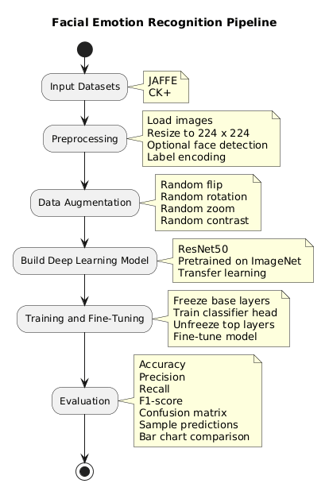
Figure 1 . Facial emotion recognition pipeline.

Figure 2 . Training and validation accuracy/loss curves for the JAFFE using ResNet50
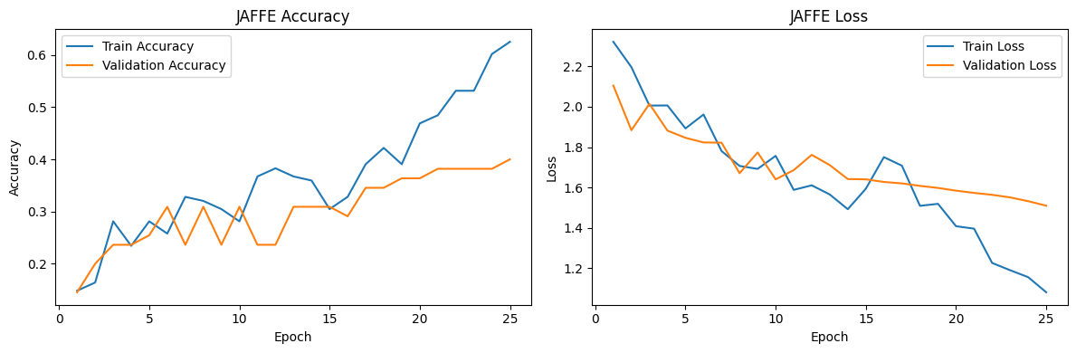
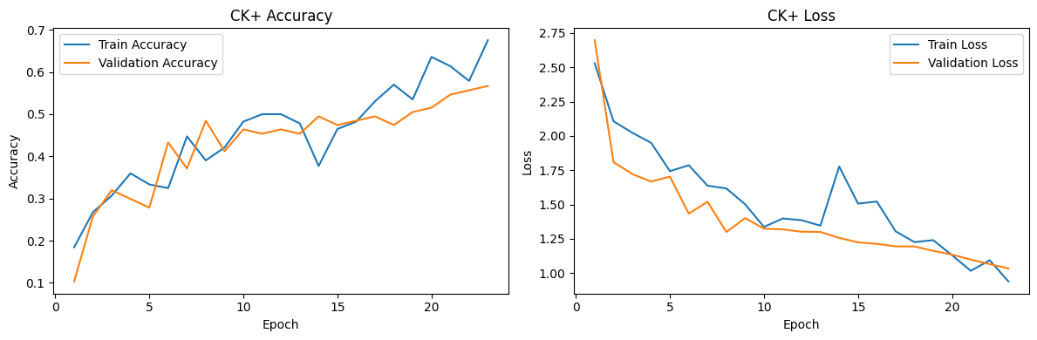
Figure 3. Training and validation accuracy/loss curves for the CK+ using ResNet50

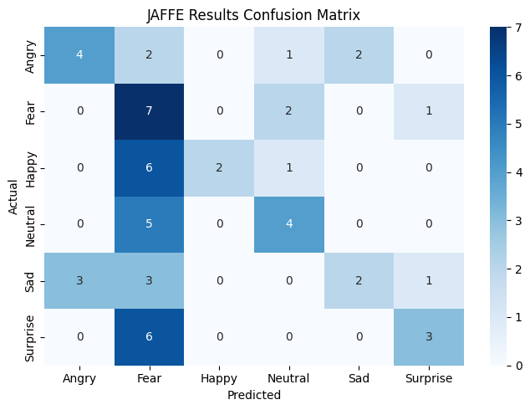
Figure 4. Confusion matrix for JAFFE using ResNet50
Figure 5. Confusion matrix for CK+ using ResNet50
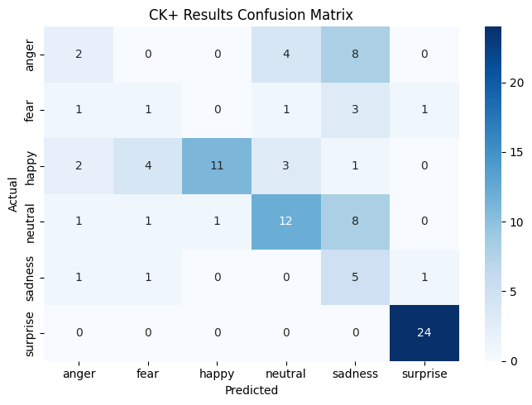
Figure 6. Sample emotion prediction
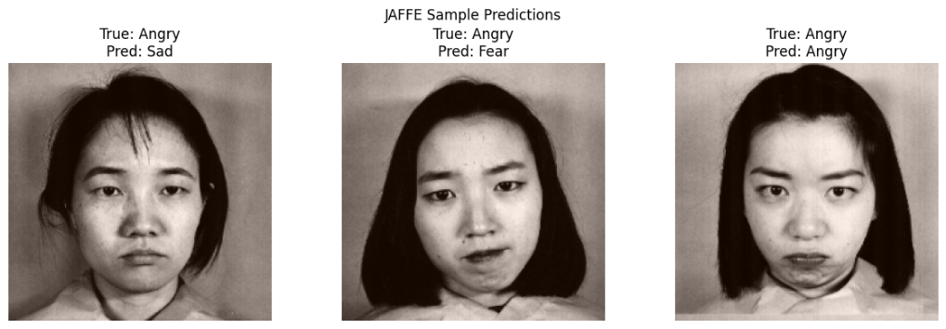
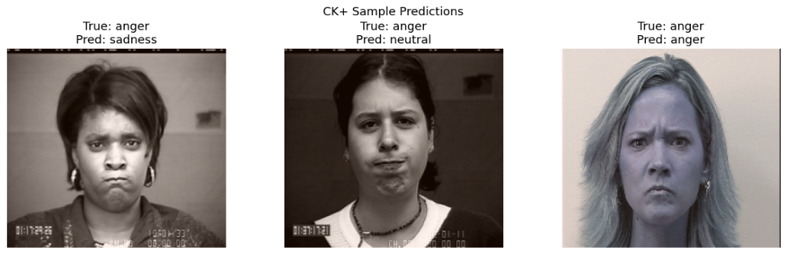
Figure 7. Accuracy Comparison
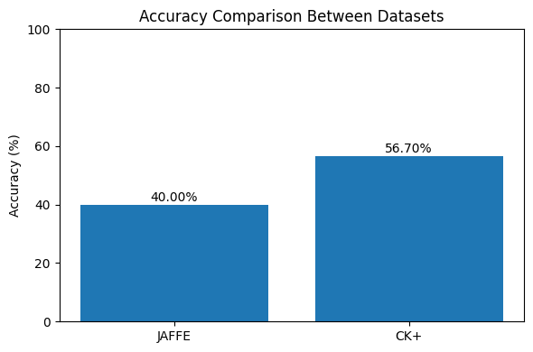

References :
LeCun, Y., Bengio, Y. and Hinton, G., 2015. Deep Learning. Nature, 521(7553), pp.436-444.
He, K., Zhang, X., Ren, S. and Sun, J., 2016. Deep Learning for image recognition. (CVPR), pp.770-778.
Pan, S.J. and Yang, Q., 2010. A survey on transfer learning. IEEE Transactions on Knowledge and Data Engineering, 22(10), pp.1345-1359.
Lyons, M. et al.(1998) JAFFE . FG Conference
Dalal, N. & Triggs, B.(2005) Histograms of oriented gradient (HOG). CVPR.

